Project Title:
Food Trends Understanding Customer preference in F&B (Food and Beverage)

CERTIFICATE

This is to certify that the project titled “Food Trends: Understanding Customer Preferences in the Food & Beverage (F&B) Industry” is a bonafide work carried out by [MADDI SRIJA] as part of the Virtual Internship Program conducted by Infosys under the course Data Visualization during the academic year 2025–2026.
This project report has been submitted in partial fulfillment of the requirements for the successful completion of the Data Visualization internship program. The work has been carried out under my guidance and supervision.

Guide
Name: Kalaiyarasi Gomathi

ACKNOWLEDGEMENT

I would like to express my sincere gratitude to Infosys for providing me the opportunity to complete the Virtual Internship in Data Visualization. This internship helped me gain practical knowledge and experience in analyzing data and creating meaningful visualizations.
I would also like to thank my faculty guide for their valuable guidance, support, and encouragement throughout the completion of this project titled “Food Trends: Understanding Customer Preferences in the Food & Beverage (F&B) Industry.” Their suggestions and feedback greatly helped me in successfully completing this project.
I am also thankful to my college and department for providing the necessary resources and support during the internship period. Finally, I would like to thank everyone who directly or indirectly helped me in completing this project successfully.

ABSTRACT
The Food and Beverage (F&B) industry is one of the fastest-growing industries worldwide. With the increasing number of restaurants, cafes, and online food delivery platforms, understanding customer preferences has become essential for business success. Customers today have a wide variety of choices, and their decisions are influenced by factors such as cuisine type, restaurant rating, service quality, pricing, and availability of online ordering.
This project focuses on analyzing food trends and customer preferences using restaurant data. The dataset contains information such as restaurant names, locations, cuisines offered, price ranges, ratings, votes, and service availability like online ordering and table booking. By analyzing this data, it becomes possible to identify patterns in customer behavior and determine which factors influence customer satisfaction.
Data visualization tools are used to represent the information through dashboards, charts, and graphs. These visualizations help in understanding customer segments, popular cuisines, and restaurant performance.
The findings from this project provide valuable insights for restaurant owners, food delivery platforms, and businesses to improve their services and marketing strategies. Understanding food trends helps businesses adapt to changing consumer demands and maintain competitiveness in the food and beverage industry.

INTRODUCTION
The Food and Beverage industry is an important part of the global economy. Restaurants, cafes, fast food chains, and food delivery services contribute significantly to employment and economic growth. Over the past decade, the industry has experienced rapid transformation due to technological advancements and changing customer lifestyles.
Consumers today expect convenience, variety, and quality when choosing food services. Online platforms have made it easier for customers to explore different cuisines, read reviews, compare prices, and order food from their preferred restaurants. As a result, customer data generated through these platforms has become a valuable resource for understanding consumer behavior.
Analyzing restaurant data can provide insights into several important aspects such as customer satisfaction, popular cuisines, pricing trends, and service preferences. Businesses can use this information to design better menus, improve customer experiences, and optimize operational strategies.
This project focuses on analyzing restaurant datasets to understand food trends and customer preferences in the food and beverage industry. By using data visualization techniques, the project aims to present the insights in a simple and interactive manner that can help businesses make better decisions.

PROBLEM STATEMENT
The food and beverage industry generates a large amount of customer data through online reviews, ratings, and restaurant platforms. However, many businesses struggle to effectively analyze this data and understand customer preferences.
Without proper analysis, restaurants may fail to identify which cuisines are popular, what customers expect from their services, and how pricing affects customer decisions. This lack of understanding can lead to poor business strategies and reduced customer satisfaction.
The problem addressed in this project is the need to analyze restaurant data to identify food trends and customer behavior patterns. By using data analytics and visualization techniques, the project aims to transform raw data into meaningful insights that can help businesses improve their services and attract more customers.

OBJECTIVE
The main objective of this project is to analyze food trends and understand customer preferences in the Food and Beverage (F&B) industry by using restaurant data. The project aims to study customer behavior based on factors such as restaurant ratings, cuisine types, price ranges, and service options like online ordering and table booking. By analyzing these factors, the project seeks to identify popular cuisines, customer satisfaction levels, and service trends. Another objective is to present the analyzed data through visualization dashboards such as charts and graphs, which help in clearly understanding the patterns and trends in customer preferences. The insights obtained from this analysis can assist restaurant owners and businesses in improving their services, enhancing customer satisfaction, and making better business decisions.

PURPOSE OF THE PROJECT
The purpose of this project is to examine and understand the changing preferences of customers in the Food and Beverage industry using data analytics and visualization techniques. In the modern food market, customers have many options and their choices are influenced by factors such as food quality, price, convenience, and online services. By analyzing restaurant datasets, this project aims to identify important trends and patterns that influence customer decisions. The project also demonstrates how data visualization tools can transform complex data into meaningful insights through dashboards and graphical representations. These insights help businesses understand customer needs, improve menu offerings, and develop better marketing strategies. Ultimately, the purpose of the project is to highlight the importance of data-driven decision-making in the food and beverage industry.

SCOPE OF THE STUDY
The scope of this project focuses on analyzing customer preferences and food trends in the Food and Beverage (F&B) industry using restaurant data. The study examines various factors such as restaurant ratings, cuisine types, price ranges, customer votes, and service options like online ordering and table booking. By analyzing these elements, the project aims to identify patterns in customer behavior and determine which factors influence customer satisfaction and restaurant popularity. The project also includes the use of data visualization dashboards to present the analyzed information through charts, graphs, and tables, making it easier to understand trends and insights. However, the scope of the study is limited to the available dataset and does not include real-time customer data or detailed customer demographics. Despite this limitation, the analysis provides valuable insights that can help restaurants and food businesses improve their services, marketing strategies, and overall customer experience.
LITERATURE REVIEW
The Food and Beverage (F&B) industry has experienced rapid growth over the past decade due to increasing urbanization, changing lifestyles, and the expansion of online food delivery platforms. Understanding customer preferences has become an important area of research for both academics and industry professionals. Many studies have focused on analyzing customer behavior, restaurant performance, and the impact of digital platforms on food consumption patterns.
Several researchers have highlighted that customer satisfaction is one of the most critical factors influencing the success of restaurants. According to previous studies, customer satisfaction depends on various factors such as food quality, service quality, restaurant environment, pricing, and menu variety. Customers tend to prefer restaurants that offer consistent quality, reasonable prices, and a pleasant dining experience. High customer satisfaction often leads to positive reviews, repeat visits, and strong brand loyalty.
In recent years, the role of online restaurant platforms and food delivery applications has significantly increased. Digital platforms allow customers to explore restaurants, compare menus, read reviews, and place orders conveniently. These platforms also generate large amounts of data related to customer ratings, reviews, and ordering behavior. Researchers have found that analyzing this data can provide valuable insights into customer preferences and emerging food trends.
Another important area of research in the F&B industry is the analysis of restaurant ratings and online reviews. Studies show that online reviews strongly influence customer decision-making. Potential customers often rely on ratings and feedback from other users before choosing a restaurant. Positive reviews and higher ratings generally increase the popularity and credibility of restaurants. On the other hand, negative reviews can significantly impact a restaurant’s reputation and customer trust.
Many researchers have also focused on cuisine popularity and food trends. Different regions often show different preferences for cuisines based on cultural background, lifestyle, and availability of ingredients. For example, some cuisines such as Italian, Chinese, and
Indian have become widely popular due to their taste, variety, and global appeal. By analyzing restaurant datasets, researchers can identify which cuisines are trending and how customer preferences change over time.
Data analytics and business intelligence tools have become essential for analyzing restaurant data. Tools such as Power BI, Tableau, and Python-based analytics platforms are widely used to visualize large datasets and identify patterns in customer behavior. These tools help analysts create dashboards that display information through charts, graphs, and maps, making it easier to interpret complex data. Visualization dashboards are especially useful for business managers because they allow quick understanding of key performance indicators such as restaurant ratings, customer engagement, and service availability.Another important factor discussed in previous studies is the impact of online ordering and delivery services. With the growth of food delivery platforms, customers increasingly prefer restaurants that offer convenient ordering options and quick delivery. Research indicates that restaurants providing online services often receive higher customer engagement and more orders compared to restaurants that rely only on traditional dine-in services. The availability of digital services has therefore become an important competitive advantage in the food industry.
Researchers have also studied pricing strategies and their influence on customer choices. Price range plays a significant role in determining customer preferences. While some customers prefer premium restaurants with high-quality dining experiences, many customers choose restaurants that offer affordable prices and good value for money. By analyzing price range data, businesses can better understand their target market and design appropriate pricing strategies.
Another area explored in the literature is customer segmentation. Customer segmentation involves dividing customers into different groups based on their behavior, preferences, and satisfaction levels. For example, customers may be classified as loyal customers, satisfied customers, or dissatisfied customers depending on their ratings and feedback. Segmenting customers helps businesses identify their most valuable customers and develop targeted marketing strategies.
The literature also emphasizes the importance of data-driven decision-making in the food industry. Businesses that use data analytics can better understand customer needs and adapt their strategies accordingly. Data-driven approaches allow restaurants to improve menu
planning, optimize pricing, enhance service quality, and design more effective marketing campaigns.
In conclusion, previous research highlights that analyzing customer data is essential for understanding food trends and improving restaurant performance. Factors such as cuisine popularity, customer ratings, service quality, pricing, and online ordering play a significant role in shaping customer preferences. Data analytics and visualization tools provide powerful methods for transforming raw restaurant data into meaningful insights. These insights can help restaurants and food businesses make informed decisions, improve customer satisfaction, and remain competitive in the rapidly evolving food and beverage industry.
METHODOLOGY
The methodology of this project explains the systematic process followed to analyze customer preferences and food trends in the Food and Beverage (F&B) industry. The study uses restaurant datasets and data visualization techniques to identify patterns in customer behavior and restaurant performance. The methodology consists of several stages including data collection, data pre-processing, data analysis, and visualization.
Data Collection
The first step in this project is the collection of restaurant data from an available dataset. The dataset contains information about various restaurants, including attributes such as restaurant name, location, cuisine type, customer ratings, number of votes, price range, and service options like online ordering and table booking. This data provides valuable information about customer preferences and restaurant performance. The collected dataset forms the foundation for further analysis and visualization.
Data Cleaning and Pre-processing
After collecting the dataset, the next step is data cleaning and pre-processing. Raw data often contains missing values, duplicate records, or inconsistent data entries that may affect the accuracy of the analysis. Therefore, the dataset is cleaned by removing duplicate records, handling missing values, and correcting formatting errors. Unnecessary columns that are not relevant to the analysis are also removed. This process ensures that the dataset is accurate, reliable, and ready for analysis.
Data Transformation
In this stage, the cleaned dataset is transformed into a structured format suitable for analysis. Important variables such as cuisine type, price range, ratings, and service availability are selected for further study. Data transformation may also involve grouping similar values, categorizing ratings, and preparing the data for visualization tools. This step helps in organizing the data in a way that
Data Analysis
Once the data is prepared, analytical techniques are applied to examine customer preferences and restaurant performance. The analysis focuses on identifying popular cuisines, understanding the distribution of restaurant ratings, and studying the impact of services such as online ordering and table booking. Customer engagement is also analyzed using factors such as the number of votes and rating levels. The analysis helps reveal patterns that indicate customer satisfaction and market demand.
Data Visualization
Data visualization is used to present the analyzed data in a graphical format that is easy to understand. Visualization tools such as dashboards, charts, and graphs are created to represent key insights from the dataset. Different types of charts such as pie charts, bar charts, line charts, and tables are used to illustrate restaurant distribution, customer segmentation, and service trends. These visualizations help users quickly interpret the data and identify important trends in customer preferences.
Dashboard Development
To make the analysis more interactive and user-friendly, multiple dashboards are developed. These dashboards display important metrics such as total restaurants, average ratings, popular cuisines, and service availability. Each dashboard focuses on a specific aspect of the analysis, such as customer segmentation, restaurant distribution, or service trends. The dashboards provide a clear overview of the data and allow users to explore different insights.
Interpretation of Results
The final stage of the methodology involves interpreting the results obtained from the analysis and visualization. The insights generated from the dashboards are examined to understand customer behavior and food trends. Based on these insights, recommendations are provided to help restaurants improve their services, enhance customer satisfaction, and make better business decisions.

TOOLS AND TECHNOLOGIES USED – POWER BI
Power BI is a powerful business intelligence and data visualization tool developed by Microsoft. It helps users analyze large amounts of data and convert it into meaningful insights through interactive dashboards and reports. Power BI allows organizations and individuals to transform raw data into visual representations such as charts, graphs, tables, and maps. These visualizations make complex data easier to understand and interpret.
Power BI is widely used in many industries including finance, healthcare, retail, and food services. It helps decision-makers understand trends, patterns, and relationships in data. With its interactive features, users can easily explore data and gain valuable insights that support better decision-making.
In this project titled “Food Trends: Understanding Customer Preferences in the Food & Beverage (F&B) Industry,” Power BI is used to analyze restaurant data and visualize customer preferences. The tool helps identify trends related to restaurant ratings, popular cuisines, service types, and customer satisfaction levels. By using Power BI dashboards, the data can be presented in a clear and interactive format, making it easier to understand customer behavior in the food and beverage industry.
Power BI provides many features that help in data analysis and visualization. One of the main features of Power BI is its ability to connect to different data sources. Users can import data from Excel files, databases, online services, and cloud platforms. After importing the data, Power BI allows users to clean and transform the data using its built-in data transformation tools.
Another important feature of Power BI is the creation of interactive dashboards. Dashboards combine multiple visualizations into a single view, allowing users to monitor key information at a glance. Users can interact with the dashboards by applying filters, selecting categories, and drilling down into specific data points.Power BI also provides a wide range of visualization options such as bar charts, pie charts, line graphs, stacked charts, tables, and maps. These visualizations help present data in an easy-to-understand format. Users can customize the design, colors, and layout of these visualizations to create clear and attractive reports.
Additionally, Power BI supports real-time data analysis. This feature allows users to view updated data and monitor changes instantly. Power BI also includes sharing and collaboration features that allow reports and dashboards to be shared with other users.
In this project, Power BI is used to analyze restaurant datasets and create interactive dashboards that show customer preferences in the Food and Beverage industry. The dataset includes information such as restaurant ratings, cuisine types, price ranges, locations, and service options like online delivery and table booking.
Power BI helps organize and analyze this information to identify important trends. For example, the dashboards can show which cuisines are most popular, how restaurant ratings are distributed, and how services like online delivery influence customer satisfaction.
Several dashboards were created using Power BI in this project. These dashboards include an overview dashboard, customer segmentation dashboard, restaurant analysis dashboard, and service analysis dashboard. Each dashboard provides a different perspective on the data and helps identify patterns related to customer preferences.
Through these visualizations, Power BI makes it easier to understand large amounts of data and draw meaningful conclusions about the food and beverage industry.
Using Power BI in this project provides several advantages. First, it helps convert raw data into clear visual insights, making it easier to understand complex information. Instead of analyzing data in tables, users can view graphical representations that highlight trends and patterns.
Second, Power BI improves the efficiency of data analysis. The software allows users to quickly create visualizations and dashboards without requiring advanced programming skills. This makes it suitable for both beginners and professionals.
Third, Power BI supports interactive exploration of data. Users can apply filters, compare categories, and explore different aspects of the dataset. This interactive capability helps identify relationships between different variables in the data.
Finally, Power BI enhances the presentation of results. The dashboards created in Power BI are visually appealing and easy to interpret. This helps communicate findings effectively to stakeholders and decision-makers.
DATASET DESCRIPTION
The dataset used in this project contains information about various restaurants and customer interactions within the Food and Beverage (F&B) industry. The dataset plays an important role in analyzing customer preferences, restaurant performance, and food trends. It includes multiple attributes related to restaurants, such as their location, cuisine types, ratings, pricing levels, and service options. By studying this data, it becomes possible to understand customer behavior and identify patterns in the food industry.
The dataset consists of a large number of records where each record represents a particular restaurant. Each restaurant entry includes several important variables that describe its characteristics and services. These variables help in analyzing different aspects of the restaurant business, including popularity, customer satisfaction, and service availability.
One of the key attributes in the dataset is the restaurant name, which uniquely identifies each restaurant in the dataset. Another important attribute is the location, which indicates the geographical area where the restaurant is situated. Location information helps in understanding how restaurants are distributed across different regions and which areas have a higher concentration of restaurants.
The dataset also includes information about cuisine types, which represents the types of food offered by the restaurants. Examples of cuisine categories may include Indian, Chinese, Italian, Fast Food, Continental, and other regional or international cuisines. This attribute is very useful for identifying the most popular cuisines and understanding customer food preferences.
Another significant attribute is the customer rating, which indicates the level of customer satisfaction with the restaurant. Ratings are typically provided on a numerical scale, such as from 1 to 5. Higher ratings generally indicate better customer experiences, while lower ratings may indicate dissatisfaction with food quality, service, or other factors.
In addition to ratings, the dataset also contains the number of votes or reviews given by customers. This attribute represents the level of customer engagement with a restaurant. A restaurant with a large number of votes generally indicates higher popularity or customer interest.
The dataset also includes the price range, which indicates the approximate cost level of dining at a restaurant. Price ranges help classify restaurants into categories such as low-cost, medium-cost, or high-cost establishments. Analyzing this attribute helps understand how pricing influences customer choices and restaurant popularity.
Another important feature included in the dataset is online ordering availability. This attribute shows whether a restaurant provides the option for customers to order food online. With the increasing popularity of online food delivery services, this feature plays a crucial role in determining customer engagement and restaurant accessibility.Similarly, the dataset includes table booking availability, which indicates whether customers can reserve tables in advance. This feature is particularly important for restaurants that offer dine-in services and want to manage customer flow efficiently.
Before performing the analysis, the dataset undergoes several preprocessing steps to ensure data quality. These steps include removing duplicate records, handling missing values, correcting inconsistent data entries, and formatting the data into a structured form suitable for analysis. Data preprocessing ensures that the results obtained from the analysis are accurate and reliable.
Overall, the dataset provides a comprehensive overview of restaurant characteristics and customer interactions in the food and beverage industry. By analyzing this dataset, valuable insights can be obtained regarding customer preferences, popular cuisines, restaurant performance, and service trends. These insights help businesses understand the market better and make informed decisions to improve their services and customer satisfaction.

DASHBOARD MODULES
Dashboard modules are an important part of this project because they help present the analyzed data in a visual and interactive format. A dashboard is a collection of charts, graphs, and tables that provide a clear overview of important information. In this project, multiple dashboard modules are created to analyze different aspects of customer preferences and food trends in the Food and Beverage (F&B) industry. Each dashboard focuses on a specific set of data insights that help understand restaurant performance and customer behavior.
Overview Dashboard
The Overview Dashboard provides a general summary of the entire dataset. It displays key information such as the total number of restaurants, the average customer rating, the number of cuisines available, and the distribution of restaurants across different locations. This dashboard helps users quickly understand the overall structure of the dataset and identify important patterns at a glance. It acts as the starting point for further detailed analysis.
Customer Segmentation Dashboard
The Customer Segmentation Dashboard focuses on analyzing customer satisfaction levels based on restaurant ratings and feedback. In this module, customers are categorized into different groups such as Loyal Fans, Satisfied Customers, and Critics. Loyal fans represent customers who consistently give high ratings, satisfied customers give moderate ratings, and critics provide lower ratings or negative feedback. This segmentation helps businesses understand different types of customers and identify areas where service improvement is needed.
Restaurant Analysis Dashboard
The Restaurant Analysis Dashboard provides insights into restaurant distribution and characteristics. It shows how restaurants are distributed across different locations and how various cuisines are represented in the dataset. Charts and graphs in this dashboard help identify which cuisines are most popular and which areas have the highest concentration of restaurants. This information can help businesses determine potential market opportunities and competition levels in different regions.
Service Analysis Dashboard
The Service Analysis Dashboard focuses on analyzing service-related features provided by restaurants. It examines factors such as the availability of online ordering and table booking services. With the increasing demand for digital convenience, many customers prefer restaurants that offer online ordering and delivery options. This dashboard helps identify how many restaurants provide such services and how these services influence customer engagement and ratings.
Strategy and Innovation Dashboard
The Strategy and Innovation Dashboard is designed to highlight emerging food trends and opportunities for business growth. This module analyzes data to identify trending cuisines, customer preferences, and areas where restaurants can improve their offerings. It may also track changes in customer ratings and service usage patterns over time. By analyzing these trends, businesses can develop innovative strategies such as introducing new menu items, improving service quality, or expanding delivery options.

Importance of Dashboard Modules
The dashboard modules collectively provide a comprehensive analysis of the restaurant dataset. They help transform raw data into meaningful insights through visual representation. By using dashboards, decision-makers can quickly identify trends, monitor performance, and make data-driven decisions. The use of dashboards also improves the clarity and effectiveness of data analysis, making it easier for users to understand customer preferences and market dynamics in the food and beverage industry.

DATA COLLECTION AND DATA CLEANING PROCESS
For this project, the dataset used to analyze customer preferences in the Food and Beverage (F&B) industry was obtained from the online data platform Kaggle. Kaggle is a popular platform that provides publicly available datasets for data analysis, research, and machine learning projects. The dataset contains various details about restaurants, including restaurant names, locations, ratings, cuisines offered, price ranges, and service features such as online delivery and table booking.
After downloading the dataset from Kaggle, it was imported into Microsoft Power BI for further analysis. Before creating dashboards, it is important to clean and prepare the data to ensure accuracy and reliability. Raw datasets often contain missing values, duplicate records, inconsistent formats, and unnecessary columns that can affect the quality of analysis.
To solve these issues, the data was cleaned using the Power Query Editor, which is a built-in data transformation tool available in Power BI. The Power Query Editor provides several options for modifying and organizing data before it is used for visualization.
During the data cleaning process, several steps were performed. First, missing or null values in important columns were identified and handled appropriately. Duplicate records were removed to ensure that each entry in the dataset represents unique information. Unnecessary columns that were not relevant to the analysis were removed to simplify the dataset. In addition, some columns were renamed and their data types were adjusted to ensure consistency and proper formatting.
After completing these transformations, the cleaned dataset became more structured and reliable for analysis. The cleaned data was then loaded into Power BI, where different charts and visualizations were created to analyze customer preferences and trends in the food and beverage industry.
Uncleaned Dataset

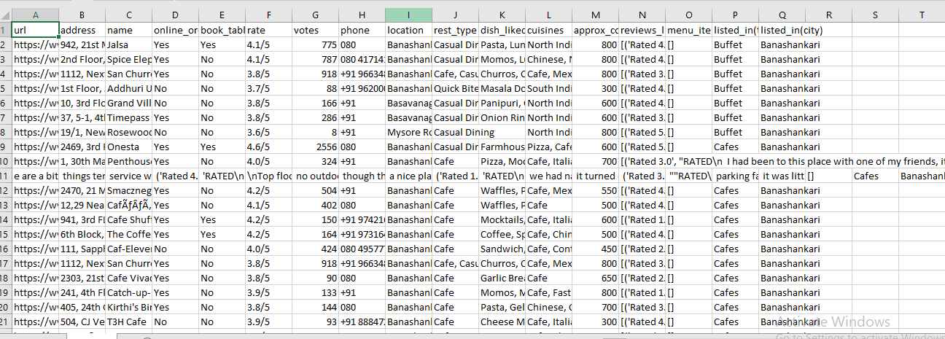
The above figure shows the raw dataset downloaded from Kaggle before any preprocessing. The dataset contains multiple columns related to restaurants, including ratings, cuisine types, locations, and service information. Some inconsistencies and unnecessary data were present in the raw dataset, which required cleaning before analysis.
Data Cleaning Using Power Query Editor

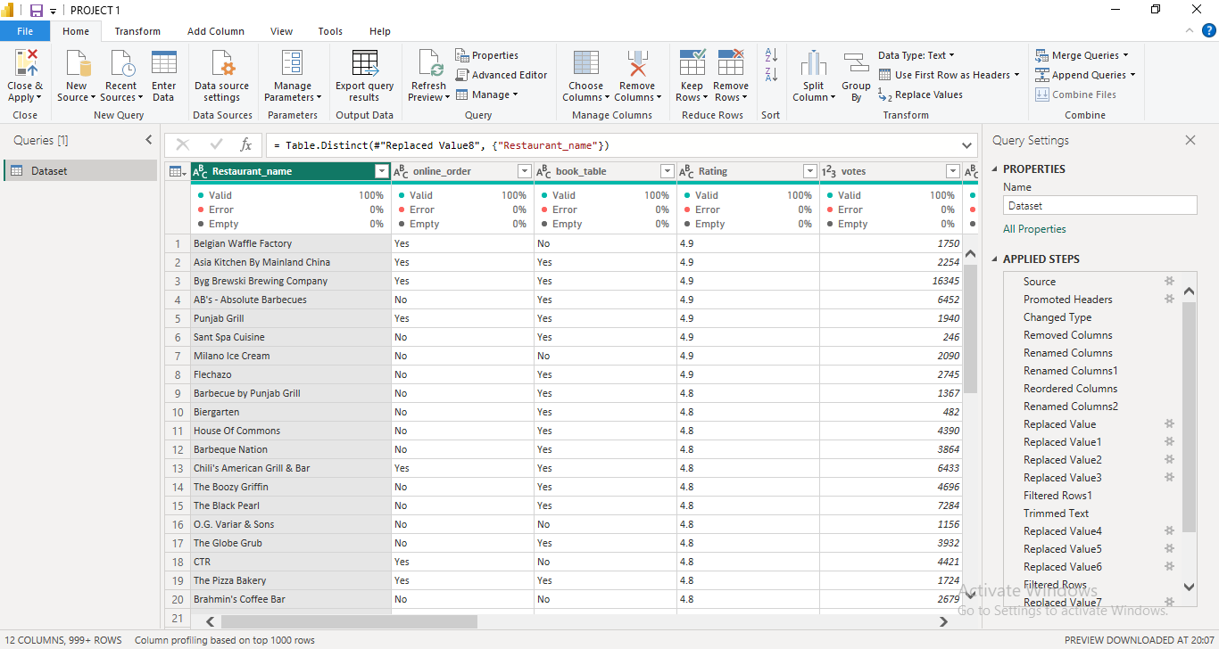

The Power Query Editor in Power BI was used to clean and transform the dataset. Several data preprocessing steps such as removing duplicates, handling missing values, and formatting columns were performed to prepare the dataset for analysis.
Cleaned Dataset
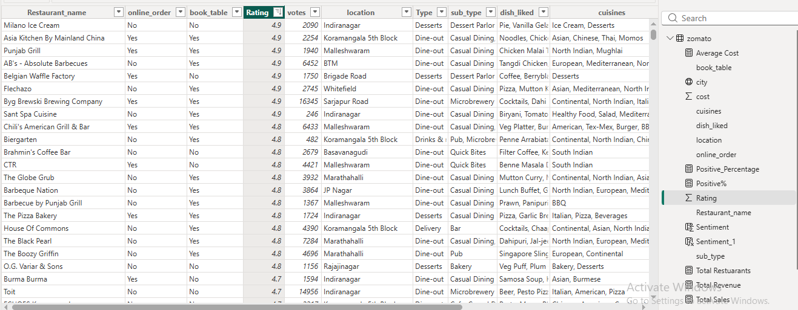
The cleaned dataset is well-structured and free from inconsistencies. This prepared dataset was then used to create interactive dashboards and visualizations in Power BI to analyze customer preferences and food trends.

DATA VISUALIZATIONS
Data visualization plays an important role in understanding complex datasets by representing them in graphical form. In this project, interactive dashboards were created using Microsoft Power BI to analyze customer preferences and food trends in the Food and Beverage industry. These dashboards help present data in an easy-to-understand format and allow users to explore insights related to restaurant ratings, customer feedback, popular cuisines, and service features.
The following dashboards were developed as part of this project:

1. Overview Dashboard
The Overview Dashboard provides a general summary of the dataset used in this project. It displays key information about restaurants, ratings, cuisines, and services available in the dataset. This dashboard helps users quickly understand the overall structure and distribution of the data.
The visualizations in this dashboard include charts that show the total number of restaurants, different cuisine types, rating distributions, and service options such as online ordering and table booking. These visuals provide a high-level understanding of the Food and Beverage industry trends.
The overview dashboard acts as a starting point for analysis and helps users gain a quick understanding of the dataset before exploring more detailed insights.
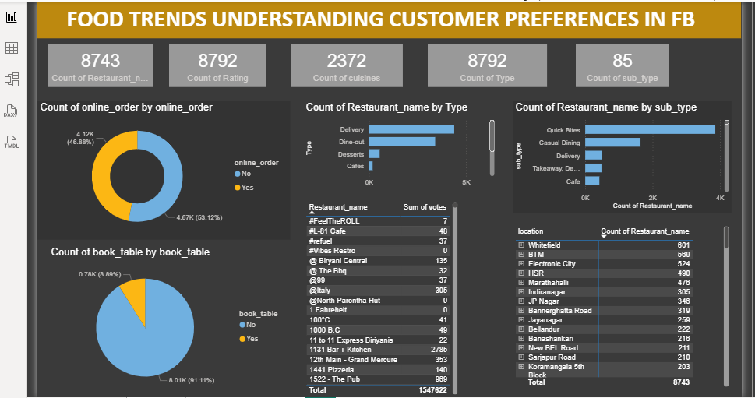
The dashboard provides a comprehensive overview of restaurant data to understand customer preferences, restaurant distribution, and service availability in the Food and Beverage (F&B) industry.
It uses Key Performance Indicators (KPIs) and various visualizations to present insights about restaurant performance, food trends, and customer engagement.
The dashboard helps businesses analyze market size, cuisine diversity, restaurant types, online ordering services, and customer engagement levels.
Key Performance Indicators (KPIs)
1. Total Restaurants
The KPI Count of Restaurant Name (8743) represents the total number of restaurants available in the dataset.
This metric provides an overview of the overall restaurant population included in the analysis. A larger number of restaurants indicates a diverse and competitive food market. This information helps researchers and business analysts understand the scale of the dataset and the coverage of restaurant businesses in the selected locations.
2. Total Ratings
The KPI Count of Rating (8792) shows the total number of ratings provided by customers.
Ratings represent customer feedback about restaurant quality and service. A higher number of ratings indicates greater customer engagement and participation. Restaurants with more ratings generally attract more customers and have higher visibility in the market.
This metric helps analyze customer interaction levels with restaurants.
3. Total Cuisines
The KPI Count of Cuisines (2372) represents the number of cuisine entries available in the dataset.
Cuisines refer to the types of food offered by restaurants, such as Indian, Chinese, Italian, Mexican, and others. A higher number of cuisines indicates greater food diversity and customer choice in the market.
This metric helps identify variety in food offerings and the richness of the food culture within the dataset.
4. Restaurant Types
The KPI Count of Type (8792) represents the total number of restaurant type records.
Restaurant types categorize restaurants based on service format, such as:
- Delivery
- Dine-out
- Cafes
- Dessert outlets
This metric helps analyze how restaurants operate and serve customers.
5. Restaurant Sub-Types
The KPI Count of Sub-Type (85) represents the number of subcategories of restaurants available in the dataset.
Sub-types provide a more detailed classification of restaurant services, such as:
- Quick Bites
- Casual Dining
- Takeaway
- Cafes
This metric helps identify different dining experiences offered to customers.
Chart Analysis
Online Order Analysis (Donut Chart)
The donut chart titled “Count of online_order by online_order” shows the proportion of restaurants that offer online ordering services.
The results indicate:
53.12% of restaurants offer online ordering services
46.88% of restaurants do not provide online ordering
This result highlights the increasing adoption of digital food ordering platforms in the food industry. Online ordering has become an important feature for restaurants because it improves convenience for customers and increases restaurant sales.
Restaurant Distribution by Type (Bar Chart)
The bar chart “Count of Restaurant Name by Type” displays the number of restaurants under different service categories.
The major restaurant types include:
- Delivery
- Dine-out
- Desserts
- Cafes
The chart shows that delivery and dine-out restaurants dominate the market, indicating strong demand for both home delivery services and in-person dining experiences.
Dessert outlets and cafes represent a smaller portion of the market but still play an important role in the overall food industry.
Restaurant Distribution by Sub-Type (Bar Chart)
The bar chart “Count of Restaurant Name by Sub-Type” provides a more detailed classification of restaurants.
Some of the common sub-types include:
- Quick Bites
- Casual Dining
- Delivery
- Takeaway
- Cafes
The chart indicates that Quick Bites restaurants have the highest count, followed by Casual Dining restaurants.
This shows that customers prefer quick, affordable, and convenient food options, which explains the popularity of quick bite restaurants.
Table Booking Analysis (Pie Chart)
The pie chart “Count of book_table by book_table” shows the percentage of restaurants that offer table booking services.
The results indicate:
91.11% of restaurants do not offer table booking
8.89% of restaurants provide table booking
This suggests that most restaurants operate without reservation systems and focus on walk-in customers or online food delivery services.
Restaurant Votes Analysis (Table Visualization)
The table visualization displays restaurant names along with the total number of votes received.
Votes represent the number of customers who rated or interacted with a restaurant. Restaurants with higher vote counts are generally more popular and widely recognized by customers.
This table helps identify restaurants that receive higher customer engagement and attention.
Restaurant Distribution by Location (Location Table)
The location table shows the number of restaurants available in different areas.
Some locations such as:
- Whitefield
- BTM
- Electronic City
- HSR
- Marathahalli
have a higher concentration of restaurants.
This indicates that restaurants are often located in areas with high population density, commercial activities, and strong customer demand.
Location analysis helps businesses identify popular dining hubs and potential markets for restaurant expansion.

2. Sentiment Analysis Dashboard
The Sentiment Analysis Dashboard focuses on analyzing customer opinions and feedback based on ratings and reviews. This dashboard categorizes customer sentiment into different groups such as positive, neutral, and negative feedback.
Through visual charts and graphs, this dashboard shows how customers feel about restaurants and their services. It helps identify which restaurants receive the most positive feedback and which areas need improvement.
Sentiment analysis helps businesses understand customer satisfaction levels and provides insights into how customer experiences influence restaurant ratings.
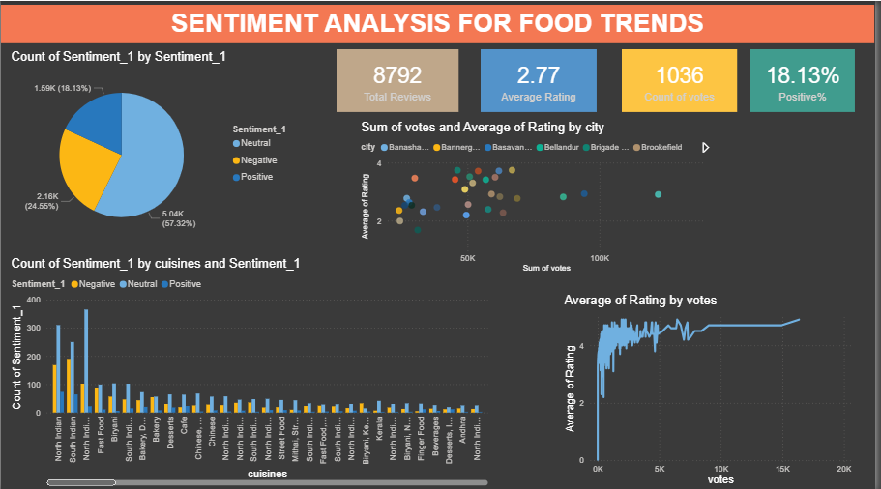
The Sentiment Analysis Dashboard analyzes customer reviews and ratings to understand customer opinions and satisfaction levels in the Food & Beverage (F&B) industry.
Sentiment analysis helps classify customer feedback into Positive, Neutral, and Negative sentiments. By analyzing these sentiments, businesses can identify strengths and weaknesses in their services and improve customer experience.
This dashboard includes several Key Performance Indicators (KPIs) and visualizations that help understand customer engagement, sentiment distribution, cuisine performance, and rating trends.
Key Performance Indicators (KPIs)
1. Total Reviews – 8792
The KPI Total Reviews (8792) represents the total number of customer reviews collected in the dataset.
Customer reviews are an important source of feedback that helps businesses understand customer satisfaction and service quality. A large number of reviews indicates that customers are actively sharing their experiences and opinions about restaurants.
This metric helps evaluate the overall level of customer interaction with restaurants.
2. Average Rating – 2.77
The KPI Average Rating (2.77) represents the average rating given by customers to restaurants.
Ratings typically range from 1 to 5, where:
1 indicates poor service
5 indicates excellent service
An average rating of 2.77 indicates that overall customer satisfaction is moderate and can be improved. Restaurants may need to improve food quality, service speed, or customer experience to increase ratings.
3. Count of Votes – 1036
The KPI Count of Votes (1036) represents the total number of votes received from customers.
Votes indicate how many customers participated in rating restaurants. Higher vote counts usually indicate higher customer engagement and restaurant popularity.
Restaurants with more votes tend to have greater visibility and credibility among customers.
4. Positive Percentage – 18.13%
The KPI Positive % (18.13%) shows the percentage of customer reviews classified as positive.
Positive reviews represent satisfied customers who had a good dining experience. However, the percentage of positive reviews is relatively low, indicating that many customers provided neutral or negative feedback.
This insight highlights the importance of improving restaurant services to increase customer satisfaction.
Chart Analysis
Sentiment Distribution (Pie Chart)
The pie chart titled “Count of Sentiment_1 by Sentiment_1” shows the distribution of customer sentiments.
The sentiments are categorized into three groups:
- Neutral Reviews – 57.32% (5.04K)
- Negative Reviews – 24.55% (2.16K)
- Positive Reviews – 18.13% (1.59K)
This chart shows that neutral reviews dominate the dataset, indicating that many customers had average experiences rather than extremely good or bad experiences.
The relatively high percentage of negative reviews suggests that restaurants may need to improve service quality, food taste, or customer support.
Sentiment by Cuisine (Bar Chart)
The bar chart titled “Count of Sentiment_1 by cuisines and Sentiment_1” compares sentiment distribution across different cuisines.
Each cuisine category shows the number of positive, neutral, and negative reviews.
Examples of cuisines included:
- North Indian
- Fast Food
- Biryani
- South Indian
- Bakery
- Desserts
- Chinese
- Street Food
This chart helps identify:
Which cuisines receive more positive feedback
Which cuisines receive more negative feedback
For example:
Some cuisines such as North Indian and Fast Food receive a large number of reviews due to their popularity.
Certain cuisines may show higher negative sentiment, indicating possible issues in taste, quality, or service.
This analysis helps restaurants understand which food categories perform well and which need improvement.
Rating vs Votes by City (Scatter Plot)
The scatter plot titled “Sum of votes and Average of Rating by city” shows the relationship between customer engagement and restaurant ratings across different cities or locations.
The chart plots:
X-axis: Total number of votes
Y-axis: Average rating
Color: Different city locations
Each dot represents a city or location.
This visualization helps identify:
Cities where restaurants receive high customer engagement
Cities where restaurants maintain higher average ratings
Cities with higher votes and higher ratings represent locations where restaurants perform well and attract strong customer satisfaction.
This information can help businesses identify high-performing markets and potential expansion areas.
Rating Trend by Votes (Line Chart)
The line chart titled “Average of Rating by Votes” shows the relationship between number of votes and average restaurant ratings.
The chart indicates that:
Restaurants with very few votes show fluctuating ratings.
As the number of votes increases, the average rating becomes more stable.
This means that restaurants with many votes generally have consistent customer feedback, making their ratings more reliable.
Highly voted restaurants often represent popular and well-established businesses

3. Product Insight and Preference Analysis
The Product Insight and Preference Analysis Dashboard focuses on identifying popular food items, cuisines, and customer preferences. This dashboard helps analyze which types of cuisines and food products are most preferred by customers.
The visualizations in this dashboard display the distribution of different cuisines, price ranges, and customer ratings. These insights help understand the relationship between food quality, price, and customer satisfaction.
This analysis is useful for restaurant owners and businesses to identify trending food products and improve their menu offerings based on customer preferences.
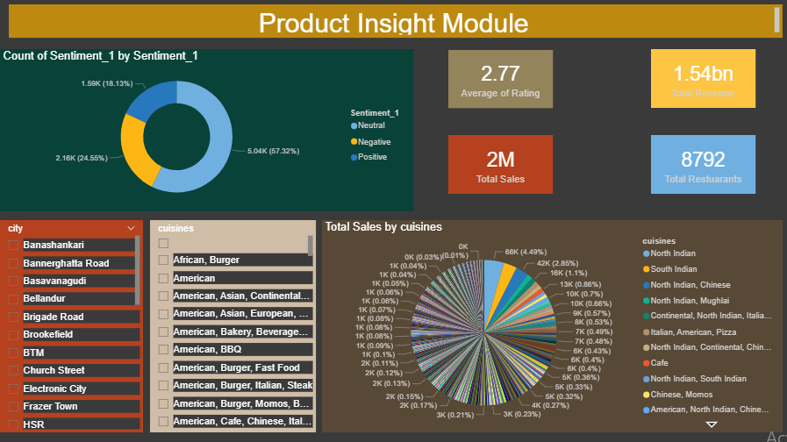
The Product Insight Module focuses on analyzing food products, cuisines, and customer feedback to understand which food categories are most popular among customers.
This module helps businesses identify high-demand cuisines, sales trends, customer sentiment, and restaurant performance. By analyzing these insights, restaurants can improve their menu planning, marketing strategies, and customer satisfaction.
The dashboard contains several Key Performance Indicators (KPIs) and visual charts that provide insights into customer sentiment, sales performance, revenue generation, and cuisine popularity.
Key Performance Indicators (KPIs)
1. Average Rating – 2.77
The KPI Average Rating (2.77) represents the average rating given by customers to restaurants or food products.
Ratings typically range from 1 to 5, where:
1 indicates very poor experience
5 indicates excellent customer satisfaction
An average rating of 2.77 suggests that the overall customer experience is moderate and needs improvement. Restaurants may need to improve aspects such as food quality, service efficiency, pricing, or customer interaction to increase customer satisfaction levels.
This metric helps businesses monitor overall product and service performance.
2. Total Revenue – 1.54 Billion
The KPI Total Revenue (1.54bn) represents the total revenue generated by restaurants or food products included in the dataset.
Revenue represents the total income generated from food sales and restaurant services.
A revenue value of 1.54 billion indicates the large financial scale of the food and beverage market represented in the dataset.
This metric helps businesses understand the economic value of food products and restaurant operations.
3. Total Sales – 2 Million
The KPI Total Sales (2M) represents the total number of food product sales recorded in the dataset.
Sales data reflects how frequently food items are purchased by customers.
Higher sales volumes indicate high demand for certain food items or cuisines.
This KPI helps identify popular food products and customer purchasing behavior.
4. Total Restaurants – 8792
The KPI Total Restaurants (8792) shows the total number of restaurants included in the analysis.
This metric helps understand the size of the restaurant network analyzed in the project.
A large number of restaurants indicates a competitive food market with diverse food options available to customers.
Chart Analysis
Sentiment Distribution (Donut Chart)
The donut chart titled “Count of Sentiment_1 by Sentiment_1” shows the distribution of customer sentiments based on reviews.
Customer feedback is categorized into three sentiment types:
- Neutral Reviews – 57.32% (5.04K)
- Negative Reviews – 24.55% (2.16K)
- Positive Reviews – 18.13% (1.59K)
The chart shows that most reviews fall into the neutral category, meaning many customers had average experiences rather than extremely positive or negative ones.
The relatively high percentage of negative reviews indicates that restaurants may need to improve food quality, service standards, or customer experience.
Sentiment analysis helps businesses understand customer opinions and improve product offerings.
City Filter (Slicer)
The city filter allows users to select specific locations such as:
- Banashankari
- Bannerghatta Road
- Basavanagudi
- Bellandur
- Brigade Road
- Brookefield
- BTM
By selecting a city, the dashboard updates all charts and KPIs to show data specific to that location.
This helps analyze local food trends and restaurant performance in different areas.
Businesses can use this information to identify high-demand markets and potential expansion areas.
Cuisine Filter (Slicer)
The cuisine filter allows users to analyze specific cuisine categories such as:
- African
- American
- Asian
- Continental
- Bakery
- BBQ
- Fast Food
- Cafe
This filter helps users focus on specific food categories and analyze their sales, ratings, and sentiment trends.
It is useful for understanding customer preferences for different cuisines.
Total Sales by Cuisines (Pie Chart)
The pie chart titled “Total Sales by Cuisines” shows the distribution of sales across different cuisines.
Examples of cuisine combinations include:
- North Indian
- South Indian
- North Indian and Chinese
- North Indian and Mughlai
- Italian and American
- Cafe
Chinese and Momos
Each segment of the pie chart represents the sales contribution of a specific cuisine or food category.
The chart helps identify:
Which cuisines generate higher sales
Which cuisines have lower customer demand
For example, cuisines like North Indian and South Indian often dominate the market because they are widely preferred by customers.
Restaurants can use this information to optimize their menu and focus on high-demand cuisines.

4. Customer Segmentation Module
The Customer Segmentation Dashboard divides customers into different groups based on their ratings and preferences. Customers can be categorized into segments such as loyal customers, satisfied customers, and dissatisfied customers.
This segmentation helps businesses understand the behavior and preferences of different customer groups. The dashboard provides visual charts that show how customers are distributed across different categories.
By identifying these segments, businesses can develop targeted strategies to improve customer satisfaction and retention.
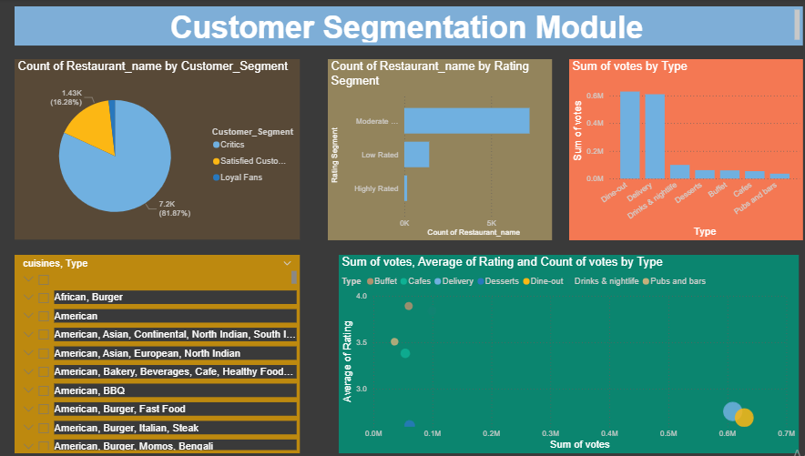
The Customer Segmentation Module focuses on analyzing different groups of customers based on their behavior, preferences, and engagement with restaurants. Customer segmentation helps businesses divide customers into groups such as critics, satisfied customers, and loyal fans based on their reviews, ratings, and interaction levels.
This analysis helps restaurants understand customer satisfaction levels, identify loyal customers, and improve services for dissatisfied customers. By studying these segments, businesses can develop better marketing strategies, customer engagement plans, and service improvements.
The dashboard includes several visual charts and filters that help analyze restaurant performance, customer ratings, and customer engagement across different service types.
1. Count of Restaurant by Customer Segment (Pie Chart)
This pie chart titled “Count of Restaurant_name by Customer_Segment” shows the distribution of restaurants based on different customer segments.
The chart divides customers into three major categories:
- Critics
- Satisfied Customers
- Loyal Fans
The data shows that:
- Critics represent approximately 7.2K restaurants (81.87%)
- Satisfied Customers represent around 1.43K restaurants (16.28%)
- Loyal Fans represent a very small percentage
This indicates that a large number of customers provide critical or moderate feedback about restaurants. Only a smaller group of customers are completely satisfied or loyal to particular restaurants.
This analysis helps businesses identify the level of customer satisfaction and areas that need improvement. Restaurants should focus on improving service quality and food experience to convert critics into satisfied and loyal customers.
2. Count of Restaurants by Rating Segment (Bar Chart)
The bar chart titled “Count of Restaurant_name by Rating Segment” categorizes restaurants based on their rating performance.
The rating segments include:
- Highly Rated
- Moderately Rated
- Low Rated
From the chart, it can be observed that:
The majority of restaurants fall under the Moderately Rated category
A smaller number of restaurants are Low Rated
Only a very small number of restaurants are Highly Rated
This indicates that most restaurants provide average customer experiences rather than exceptional services.
Restaurants in the Low Rated category may need improvements in food quality, hygiene, service efficiency, or pricing. On the other hand, highly rated restaurants represent successful business models that attract strong customer satisfaction.
3. Sum of Votes by Type (Bar Chart)
The bar chart titled “Sum of votes by Type” represents the total number of customer votes received by different types of restaurant services.
The restaurant types include:
- Dine-out
- Delivery
- Drinks & Nightlife
- Desserts
- Buffet
- Cafes
- Pubs and Bars
The chart shows that:
Dine-out restaurants receive the highest number of votes
Delivery services also receive a large number of votes
Other categories such as desserts, cafes, and pubs receive comparatively fewer votes
This indicates that customers primarily engage with restaurants through dine-in experiences and food delivery services.
Restaurants offering dine-out and delivery services tend to have higher customer engagement and popularity.
4. Cuisine and Type Filter (Slicer)
The Cuisine and Type filter allows users to select specific food categories and restaurant service types.
Examples include:
- African, Burger
- American
- American, Asian, Continental
- American, Bakery, Beverages
- American, BBQ
- American, Burger, Fast Food
- American, Burger, Italian, Steak
This filter helps analyze customer behavior for specific cuisine combinations. When a cuisine is selected, the dashboard automatically updates all charts and metrics to show data related to that particular cuisine.
This allows businesses to understand which cuisines attract more customers and generate higher engagement.
5. Relationship Between Votes, Ratings, and Restaurant Type (Scatter Plot)
The scatter plot titled “Sum of votes, Average of Rating, and Count of votes by Type” shows the relationship between:
Total customer votes
Average restaurant rating
Restaurant service type
The axes represent:
X-axis: Sum of votes (customer engagement)
Y-axis: Average rating (customer satisfaction)
Each bubble in the chart represents a restaurant type, such as dine-out, delivery, cafes, buffet, desserts, or pubs.
The size of the bubble represents the number of votes received.
From the chart, we can observe that:
Dine-out and Delivery restaurants receive the highest number of votes, indicating strong customer engagement.
Some restaurant types may have higher ratings but fewer votes, meaning they provide good service but are less popular.
Other categories may have more votes but moderate ratings, indicating high popularity but average customer satisfaction.
This analysis helps businesses understand which restaurant types are both popular and highly rated.

5. Strategy and Innovation Dashboard
The Strategy and Innovation Dashboard provides insights that help businesses develop better strategies for improving customer satisfaction and restaurant performance. This dashboard highlights areas where restaurants can improve their services, pricing strategies, and customer experience.
The visualizations in this dashboard help identify key opportunities for innovation in the Food and Beverage industry. It supports decision-making by providing insights into customer trends and market opportunities.
This dashboard helps businesses design better strategies to attract customers and remain competitive in the market.
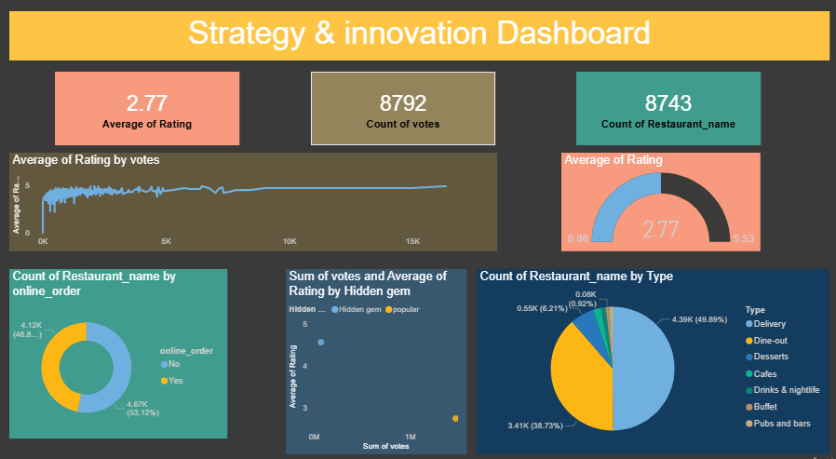
The Strategy & Innovation Dashboard focuses on analyzing restaurant performance, customer engagement, and business strategies in the Food & Beverage industry.
This dashboard helps identify growth opportunities, customer preferences, and innovative business strategies by analyzing ratings, votes, restaurant types, and online ordering patterns.
The dashboard provides insights that help restaurant owners and businesses improve their service quality, adopt digital strategies, and expand their market reach.
The dashboard includes Key Performance Indicators (KPIs) and multiple data visualizations to analyze restaurant performance and customer behavior.
Key Performance Indicators (KPIs)
1. Average Rating – 2.77
The Average Rating (2.77) represents the overall average rating given by customers to restaurants in the dataset.
Ratings usually range from 1 to 5, where:
1 indicates poor customer experience
5 indicates excellent customer satisfaction
An average rating of 2.77 indicates that most restaurants provide moderate customer satisfaction.
This suggests that restaurants need to improve areas such as:
Food quality
- Customer service
- Pricing strategies
- Dining experience
Improving these factors can help restaurants increase their ratings and customer loyalty.
2. Count of Votes – 8792
The Count of Votes (8792) represents the total number of customer votes or feedback collected in the dataset.
Votes indicate customer engagement and participation in rating restaurants.
A higher number of votes suggests that customers are actively sharing their opinions and experiences.
This metric helps businesses measure customer interaction levels and restaurant popularity.
3. Count of Restaurants – 8743
The Count of Restaurant Name (8743) represents the total number of restaurants included in the dataset.
This large number shows that the dataset represents a large and competitive food market.
Analyzing a large number of restaurants allows businesses to identify industry trends, competition levels, and market opportunities.
1. Average Rating by Votes (Line Chart)
This line chart titled “Average of Rating by Votes” shows the relationship between customer votes and restaurant ratings.
X-axis: Number of votes
Y-axis: Average rating
The chart shows that:
Restaurants with low votes show fluctuating ratings because fewer customer reviews can cause ratings to vary significantly.
As the number of votes increases, the average rating becomes more stable and consistent.
This indicates that restaurants with many votes tend to have more reliable ratings because they are based on feedback from a larger number of customers.
This analysis helps identify popular restaurants with strong customer engagement.
2. Average Rating (Gauge Chart)
The gauge chart visually represents the overall average rating of 2.77.
The gauge scale ranges from 0 to around 5.5, representing the possible rating range.
This visualization helps quickly understand the overall performance of restaurants.
Since the rating value is closer to the middle of the scale, it indicates that the overall customer satisfaction level is moderate.
Restaurants should aim to increase ratings closer to 4 or 5 to achieve higher customer satisfaction.
3. Online Order Analysis (Donut Chart)
The donut chart titled “Count of Restaurant_name by online_order” shows the number of restaurants that provide online ordering services.
The categories include:
- Yes – Restaurants offering online orders
- No – Restaurants not offering online orders
The chart shows:
- 4.67K restaurants (53.12%) offer online ordering
- 4.12K restaurants (46.8%) do not offer online ordering
This indicates that more than half of the restaurants have adopted digital ordering systems.
Online ordering is an important innovation strategy that helps restaurants:
Increase convenience for customers
Expand delivery services
Improve sales and customer reach
Restaurants that do not provide online ordering may lose potential customers.
4. Hidden Gems vs Popular Restaurants (Scatter Plot)
The scatter plot titled “Sum of votes and Average of Rating by Hidden Gem” compares two types of restaurants:
Hidden Gems
Popular Restaurants
The axes represent:
X-axis: Sum of votes
Y-axis: Average rating
Hidden gem restaurants are those that may have high ratings but fewer votes, meaning they provide good quality but are less known to customers.
Popular restaurants have higher votes, meaning they attract more customers and have greater visibility.
This analysis helps businesses identify potential restaurants that can become popular if marketed properly.
Hidden gems represent opportunities for strategic promotion and marketing.
5. Restaurant Type Distribution (Pie Chart)
The pie chart titled “Count of Restaurant_name by Type” shows the distribution of restaurants based on service types.
The restaurant types include:
- Delivery
- Dine-out
- Desserts
- Cafes
- Drinks & Nightlife
- Buffet
- Pubs and Bars
From the chart, we can observe that:
Delivery services represent the largest portion (around 49.89%)
Dine-out restaurants represent around 38.73%
Other categories such as desserts, cafes, and nightlife represent smaller portions
This indicates that delivery and dine-out services dominate the food market.
The increasing popularity of delivery services reflects changing customer preferences toward convenience and digital food ordering platforms.

KEY FINDINGS
The analysis of the restaurant dataset provided several important insights into customer preferences and food trends in the Food and Beverage (F&B) industry. By examining factors such as cuisine types, customer ratings, service availability, and restaurant distribution, meaningful patterns were identified that help understand customer behavior and market demand.One of the major findings of the analysis is that certain cuisines are significantly more popular than others. Customers tend to prefer a few specific cuisines that offer a variety of flavors and dishes. Restaurants that provide popular cuisines often receive higher ratings and more customer engagement compared to those offering less common cuisine types. This indicates that cuisine popularity plays an important role in attracting customers.
Another important finding is related to customer ratings and satisfaction levels. Most restaurants receive moderate ratings, indicating that customers generally have an average to good experience. However, only a smaller percentage of restaurants achieve very high ratings. This suggests that maintaining high service quality and food standards is essential for restaurants to stand out in a competitive market. The analysis also shows that restaurants offering online ordering and delivery services attract more customers. With the increasing use of digital platforms, customers prefer restaurants that provide convenient ordering options. Restaurants that support online services tend to have higher customer engagement and a larger number of votes or reviews. Another observation from the dataset is that restaurant distribution varies across locations. Some areas have a high concentration of restaurants, indicating strong competition in those regions. In contrast, other areas have fewer restaurants, which may represent potential opportunities for new businesses.
The study also highlights the impact of price range on customer choices. Restaurants that offer affordable pricing with good quality food tend to attract a larger number of customers. While premium restaurants also have a customer base, the majority of customers prefer restaurants that provide value for money.
Overall, the findings demonstrate that factors such as cuisine popularity, service quality, online ordering availability, location, and pricing significantly influence customer preferences in the food and beverage industry. These insights can help restaurants and food businesses make better strategic decisions to improve their services and increase customer satisfaction.
EXPECTED OUTCOMES

The expected outcome of this project is to gain a clear understanding of customer preferences and emerging food trends in the Food and Beverage (F&B) industry through data analysis and visualization. By analyzing the restaurant dataset, the project is expected to identify popular cuisines, customer satisfaction levels, and the factors that influence customer decisions when choosing restaurants. The study will provide insights into how elements such as restaurant ratings, price ranges, location, and service options like online ordering and table booking affect customer behavior. Another expected outcome is the development of interactive dashboards that visually represent the analyzed data through charts and graphs, making it easier to interpret trends and patterns. These insights will help restaurant owners and businesses understand customer needs, improve service quality, optimize menu offerings, and design better marketing strategies. Overall, the project is expected to demonstrate how data-driven analysis can support better decision-making and enhance business performance in the food and beverage industry.

RECOMMENDATIONS
Based on the analysis of food trends and customer preferences in the Food & Beverage (F&B) industry, the following recommendations can help businesses improve their performance and customer satisfaction:
- Focus on Popular Cuisines: Restaurants should prioritize offering cuisines that are trending in their region, while also experimenting with fusion dishes to attract diverse customer groups.
- Enhance Online Services: Since online ordering and delivery strongly influence customer engagement, businesses should invest in reliable digital platforms and ensure quick, seamless delivery experiences.
- Leverage Customer Feedback: Ratings and reviews are critical in shaping customer decisions. Restaurants should actively monitor feedback, respond to concerns, and use insights to improve food quality and service.
- Adopt Flexible Pricing Strategies: Offering a mix of affordable options alongside premium experiences can help cater to different customer segments and maximize reach.
- Use Data-Driven Marketing: Customer segmentation dashboards can guide targeted promotions—such as loyalty programs for repeat customers or discounts for critics—to improve retention and satisfaction.
- Innovate Continuously: Tracking emerging food trends allows businesses to introduce new menu items, seasonal specials, or healthier alternatives that align with evolving consumer demands.
FUTURE SCOPE
While this project provides valuable insights into customer preferences using restaurant datasets, there are several opportunities to expand the study further:
- Integration of Real-Time Data: Future research can incorporate live data from food delivery platforms and restaurant apps to capture dynamic changes in customer behavior.
- Sentiment Analysis: Analyzing customer reviews and social media posts using natural language processing (NLP) can provide deeper insights into customer emotions and satisfaction levels.
- Predictive Analytics: Machine learning models can be applied to forecast emerging food trends, helping restaurants anticipate customer demands and plan menus proactively.
- Demographic Insights: Including customer demographics such as age, gender, and income levels could allow businesses to design more personalized strategies.
- Cross-Regional Comparisons: Expanding the dataset to multiple regions or countries can highlight cultural differences in food preferences and global cuisine trends.
- Sustainability and Health Trends: Future studies could also explore how growing interest in healthy eating, plant-based diets, and sustainable practices influence customer choices.

CONCLUSION
This project demonstrates the importance of data analytics and visualization in understanding customer preferences within the F&B industry. By analyzing restaurant datasets through Power BI dashboards, valuable insights were obtained regarding cuisine popularity, service preferences, pricing strategies, and customer satisfaction levels.
The findings highlight that customer decisions are influenced not only by food quality and pricing but also by convenience factors such as online ordering and table booking. Restaurants that adapt to these preferences are more likely to achieve higher engagement and long-term success.
Ultimately, the study emphasizes that data-driven decision-making is essential for competitiveness in the modern food market. Businesses that leverage analytics to understand customer behavior can refine their services, strengthen customer relationships, and remain resilient in a rapidly evolving industry.

